Personal information:

Last Name:
First Name:
Title:
Company:
Department:
Country:
Telephone:
Mobile:
E-mail address:

Copyright, Author agreement, Streaming & recording
As an author, I agree to grant copyright ownership of material contained in my proceedings manuscript and the lecture to the EVECC Congress. I do grant unlimited and non-exclusive Publication rights for any and all of these materials to EVECC congress for the purpose of publishing the materials and distributing in various modes and on the internet (online).

In turn, EVECC congress grants me, the author, unlimited subsequent re-use of the submitted materials. I agree that EVECC congress may copy proof submissions but that editing will not change content or meaning.

VIN partnership
EVECC congress has a partnership with VIN (https://www.vin.com/vin), meaning VIN will retain and use the congress proceedings as content on their platform. The congress proceedings will be made accessible to their members for an unlimited period of time. This means that VIN will save your lecture notes, congress proceedings on their website and these can be accessed by their members or be used for continuing education.

Hybrid meeting & recordings
As the congress will be hosted physically, all lectures may be streamed and/or recorded during the live presentations onsite. These recordings will be only accessible for registered delegates of the 22nd EVECC congress. The recorded streams are available for three months after the congress via a closed platform.
EVECCS Members or VECCS/EVECCS combined members
These recordings will be edited into separate presentations per day, per stream and per speaker. These presentations will remain available online for the EVECCS and ECVECC members for a period of one year to be viewed on demand via the EVECC society website.

☐ Yes, I agree

Conflicts of interest
Do you have any conflicts of interest to disclose? ☐ Yes ☐ No
If yes, please fill the below overview in full.

Disclosure Form
Please complete all sections of this form, and provide details of any items relevant to your talk(s). For each disclosure, please list the item, and the external body that it involves. Where relevant, please include items that apply to a member of your immediate family, or to another close personal connection you have (e.g., spouse, partner, etc).

Category | Relevant disclosures
Current employment and any previous employment in which you continue to have a financial interest
Investments/commercial interests
Patents held or pending
Paid Speaking engagements
Consultancies
Participation in research funded by or using items of commercial interest from an external body
Other grants/research
Gifts, hospitality, or any other benefits (whether taken or not)
Support for attending meetings (e.g. travel, accommodation, subsistence, congress fees)
Membership of advisory boards or expert panels
Membership of any professional bodies, special interest groups or mutual support organisations
Any other conflicts that are not covered by the above

To the best of my knowledge, the above information is complete and correct. I give my consent for this information to be used by the EVECC Congress.
Signed:
Name:
Date:
Disclosure policy
Please note that the information you provide will be directly associated with your speaker details and all your manuscripts. All delegates will be able to view the information provided.

It is a requirement of our congress that all speakers complete this disclosure form and summarize the information in their associated disclosure slide (slide 2 of your presentation). Please provide details of all interactions that you have with external bodies that might have influenced, or had the potential to influence, the information you will give in your talk(s). The most relevant disclosures arise when the speaker has a relationship (financial or otherwise) with an external body that has a commercial interest in an item relevant to the topic.

Such items include but are not limited to:
o Drugs
o Instruments
o Equipment
o Devices
o Assays
o Printed and electronic matter e.g., journals, books, websites, and other electronic resources
o Any form of service provision

However, there may also be associations with non-commercial external bodies that might also have influenced, or had the potential to influence, the information provided. These should also be reported.

In completing the form, an element of common sense is allowed. The main mantra is to do your best to provide a complete overview of all relevant items. If there is any doubt, it is best to practise full disclosure and report everything, even if you are uncertain of its relevance.

If you are unsure about what to include, or have concerns about disclosing items, please contact the scientific committee via sc@eveccs.org to discuss the matter.

Where there are numerous items for a particular category (see example), it is acceptable to summarise items within a particular timeframe. For example, a timeframe of 5 years would be acceptable in such cases.

Use of abbreviations (for societies, groups, charities etc) is acceptable provided that they are well known and/or can easily be deduced (i.e. found with a simple Google search). If in doubt, please give the name in full.

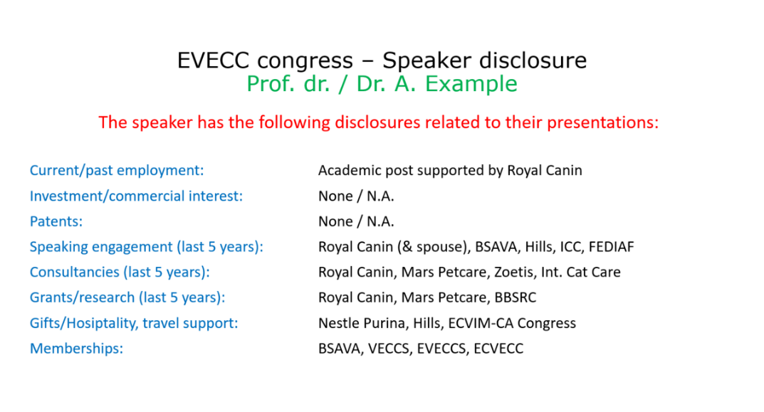
Example disclosure slide:

